5.65: a) The instrument has mass 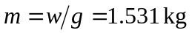. Forces on the instrument:
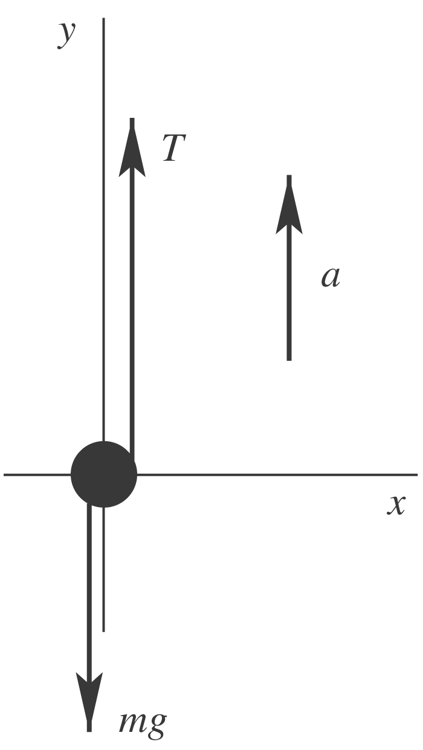
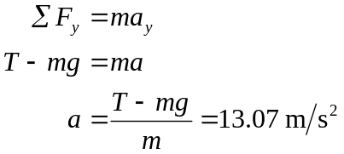
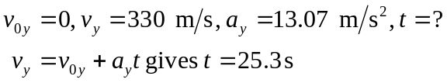
Consider forces on the rocket; rocket has the same 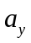. Let F be the thrust of the rocket engines.
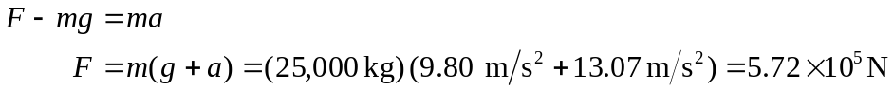
b)

